Linux File Ownership and Permission Demonstration with Group Access Control

What are filesystem permissions?

Filesystem permissions are rules that control who can read, write, or execute files and directories on a computer system. They are essential for security and multi-user environments, preventing unauthorized access or changes.

Common Permission Types

For most systems (like Linux/Unix, macOS, and even Windows in a different form), permissions fall into three basic types:
- Read (r) – The ability to view or open a file’s contents.
For directories: list the files inside.
- Write (w) – The ability to modify a file’s contents or create/delete files in a directory.
- Execute (x) – The ability to run a file (if it’s a program/script).
- For directories: the ability to enter the directory and access files inside.

Permission Categories (Linux/Unix style)

Permissions are usually divided into three groups:
- Owner (u) → The user who owns the file.
- Group (g) → Users who belong to the file’s group.
- Others (o) → Everyone else.
Example (from ls -l command): -rwxr-xr--
This breaks down as:
rwx → owner has read, write, execute
r-x → group has read, execute
r-- → others can only read

Numeric (Octal) Representation

Permissions are also represented using numbers:
r = 4, w = 2, x = 1
Add them up for each role.
Examples:
7 = rwx (4+2+1)
6 = rw- (4+2)
5 = r-x (4+1)
So:
chmod 755 file
means:
Owner → rwx (7)
Group → r-x (5)
Others → r-x (5)

You have four Linux terminal windows, each logged in as a different user on the same system (indlvrh91). This setup is typically used to demonstrate permissions, ownership, and user isolation.

User Details and Home Directories

Each user has their own home directory. The 'administrator' group is shared by multiple users, allowing for group-based file access control.

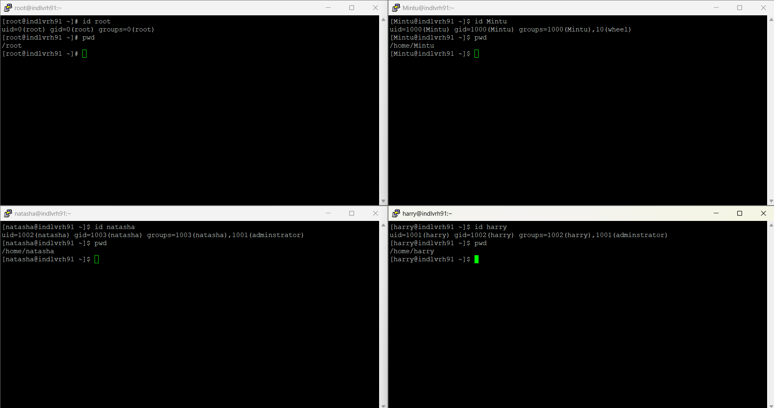

User | UID | GID | Primary Group | Secondary Groups | Home Directory | Privilege Level
root | 0 | 0 | Root | root | /root | Superuser (full control)
Mintu | 1000 | 1000 | Mintu | wheel | /home/Mintu | Regular user with sudo
harry | 1001 | 1002 | Harry | administrator | /home/harry | Regular user, shared group
natasha | 1002 | 1003 | Natasha | administrator | /home/natasha | Regular user, shared group

Case 1:

You have four terminal windows, each logged in as a different user:
Top left: root
Top right: Mintu
Bottom left: natasha
Bottom right: harry
They are all working in the same directory:
/myscripts
Inside this directory, there’s a shell script called script.sh.

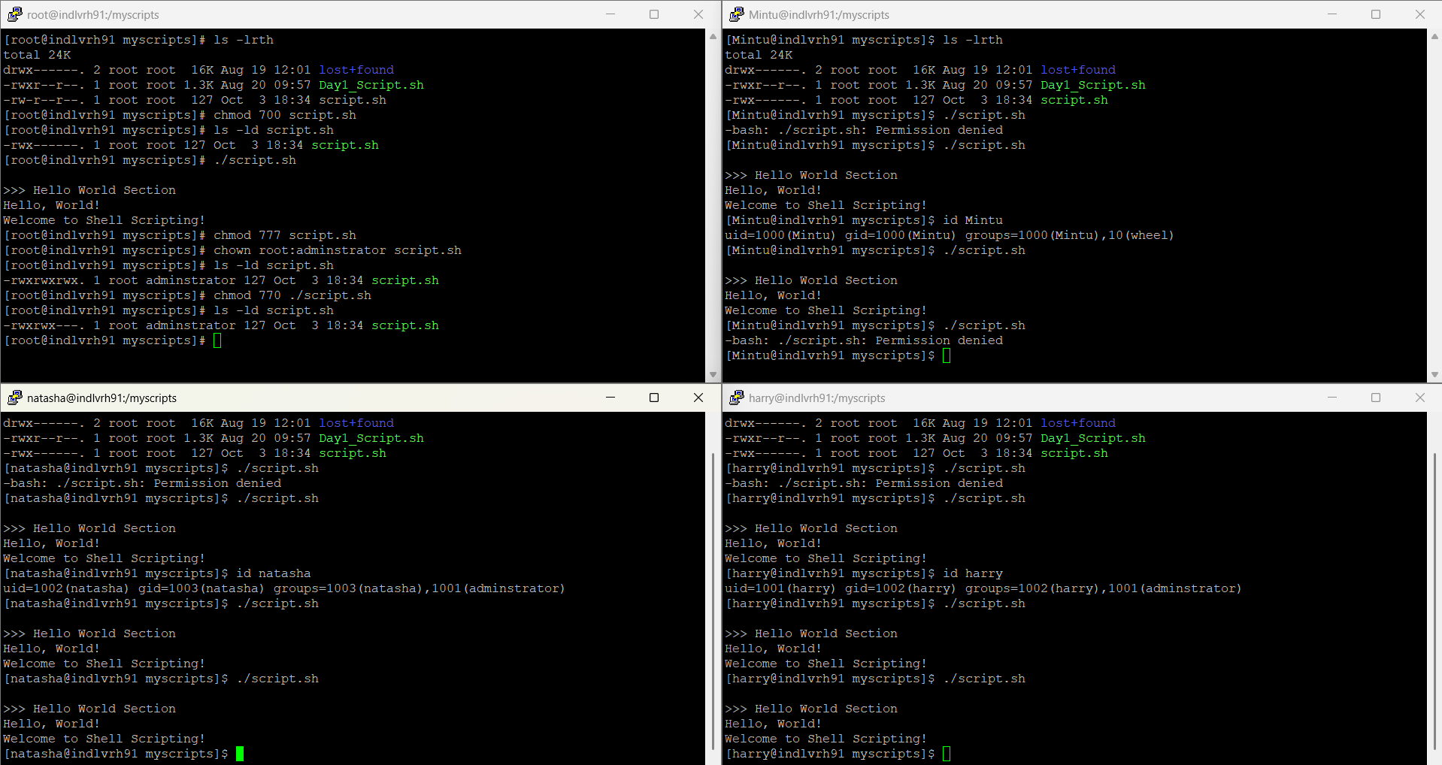

User | Belongs to Group | Group on File | Permission Status | Result
root | root | administrator | Owner → rwx | ✅ Works
Mintu | wheel | administrator | Others → --- | ❌ Denied
natasha | administrator | administrator | Group → rwx | ✅ Works
harry | administrator | administrator | Group → rwx | ✅ Works

Key Takeaways
- chmod 770 means only owner and group can use the file.
- chown root:administrator script.sh made the group “administrator” the controlling group.
- Anyone not in that group (like Mintu) can’t even read or execute it.
This is how group-based access control works in Linux.

Summary:
- Root created a script and restricted it to themselves and members of administrator.
- natasha and harry could run it because they belong to that group.
- mintu could not, because they don’t.

Case 2:

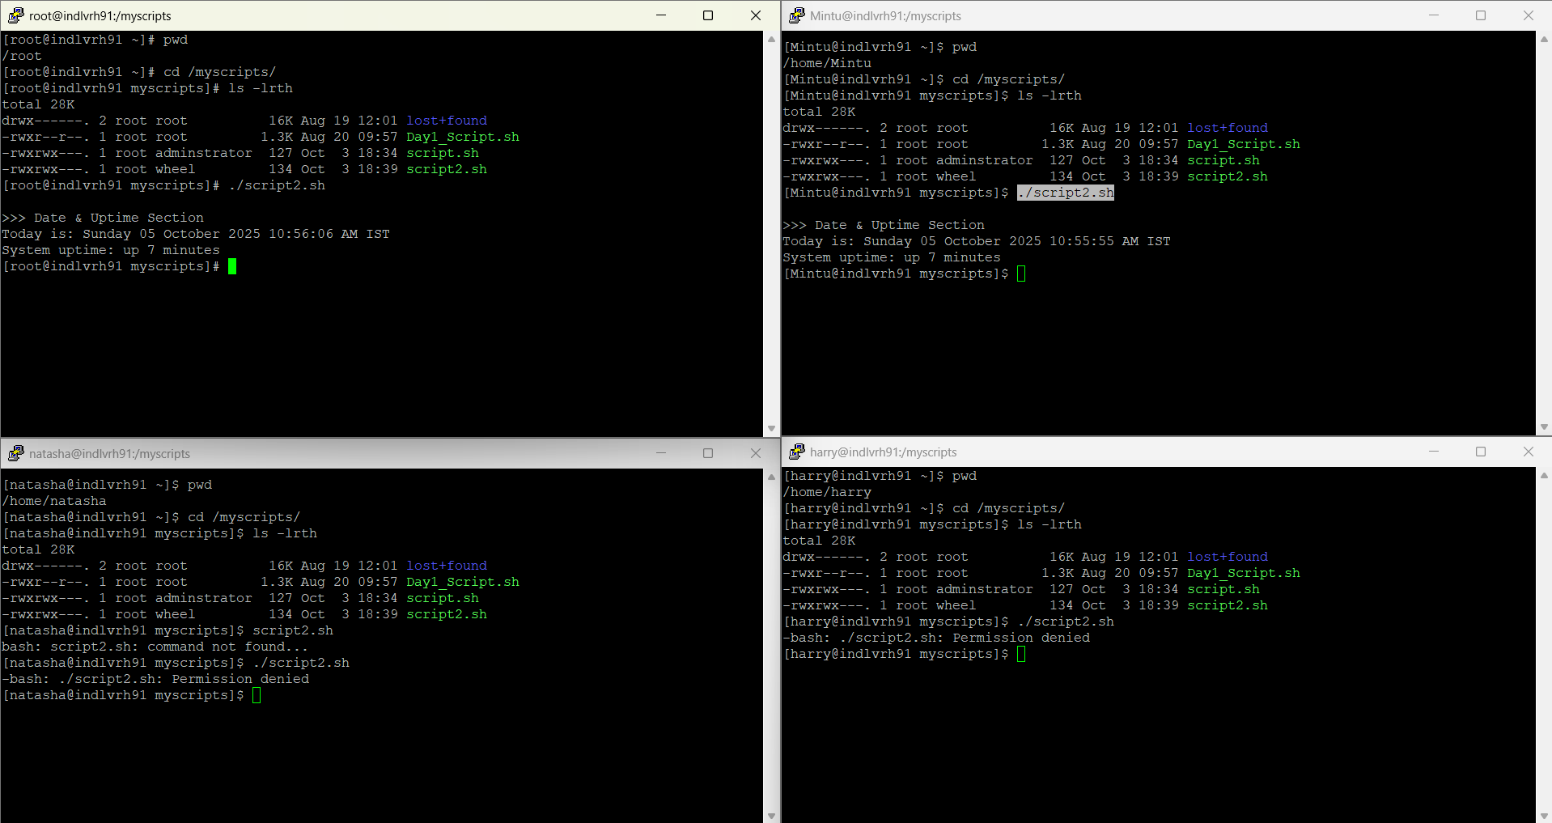

User | Belongs to Group | Group on File | Permission Status | Result
root | root | administrator | Owner → rwx | ✅ Works
Mintu | wheel | administrator | Group → rwx | ✅ Works
natasha | administrator | administrator | Others → --- | ❌ Denied
harry | administrator | administrator | Others → --- | ❌ Denied

Key Takeaways
- chmod 770 means only owner and group can use the file.
- chown root:wheel script2.sh made the group “administrator” the controlling group.
- Anyone not in that group (like natasha and harry) can’t even read or execute it.
This is how group-based access control works in Linux.

Summary:
- Root created a script and restricted it to themselves and members of wheel.
- mintu could run it because they belong to that group.
- natasha and harry could not, because they don’t.

Case 3:

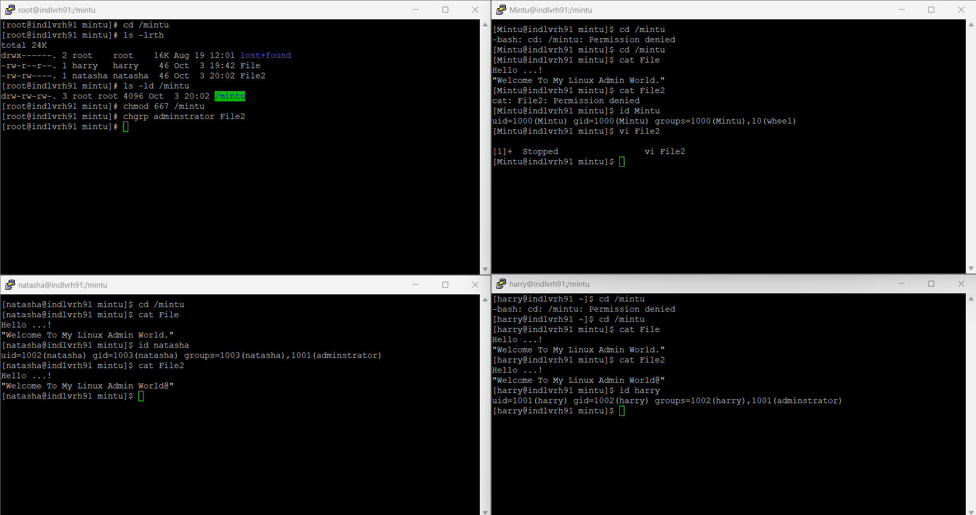

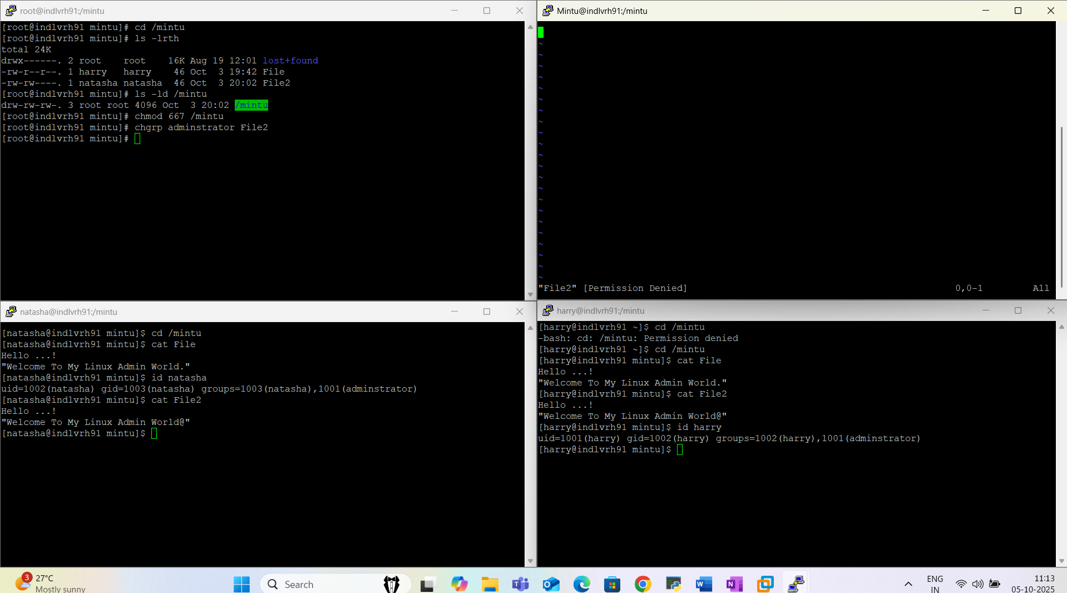

User | Belongs to Group | Group on File | Permission Status | Result
root | root | administrator | RootUser → rwx | ✅ Works (SuperAdmin)
Mintu | wheel | administrator | Others → --- | ❌ Denied
natasha | administrator | administrator | Owner → rw- | ❌ Denied
harry | administrator | administrator | Group → rw- | ❌ Denied

*Note: Super Admin or root admin has all access and permissions*

Key Takeaways
- chmod 667 means only owner and the group can use for R/W and others having all permisson.
- chgrp administrator File2 made the group “administrator” the controlling group.
- Anyone not in that group (like Mintu) can’t even read or execute it.
This is how group-based access control works in Linux.

Summary:
- natasha and harry could run it because they belong to that group.
- Mintu could not, because they don’t have access -rwx-
- Harry and natasha could run it because they belong to that group.

Special Permission Bits in Linux:

1. SUID (Set User ID)
Purpose: When a file has the SUID bit set, it runs with the permissions of the file owner, not the user who runs it.
Example:
Let’s say you have a script or binary owned by root:
[root@indlvrh91 mintu]# chmod u+s File
This sets the SUID bit on File. Now when any user runs File, it executes with the owner's privileges (in this case, Mintu).

Check:
[root@indlvrh91 mintu]# ls -l
-rwsr--r-- 1 Mintu wheel 46 Oct 3 19:42 File
Note the s in the owner's execute position (rws).

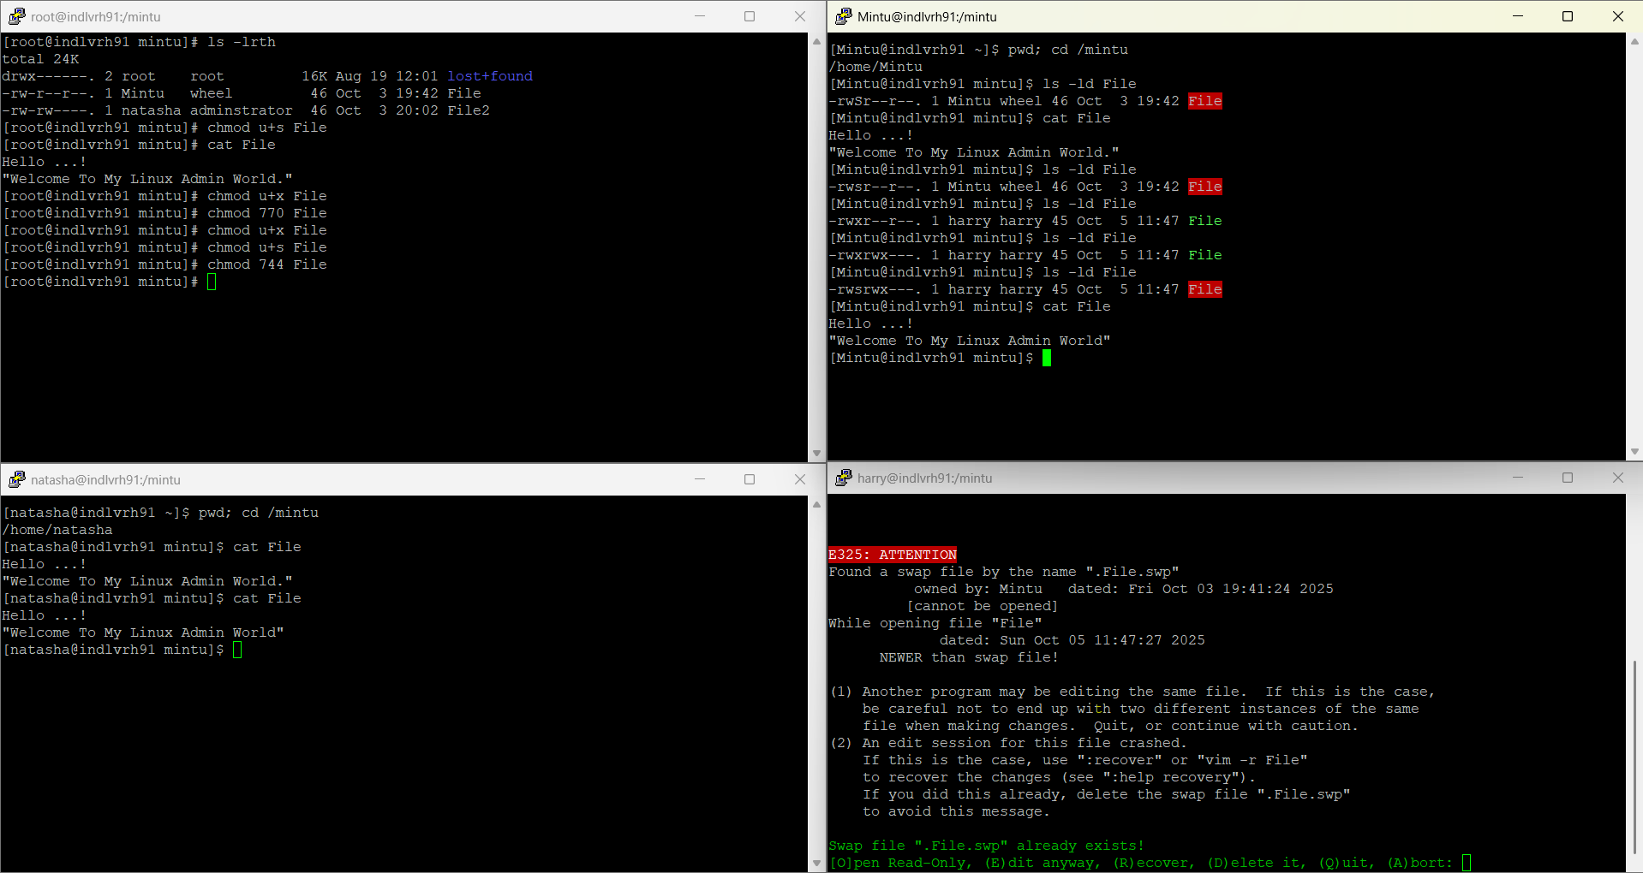

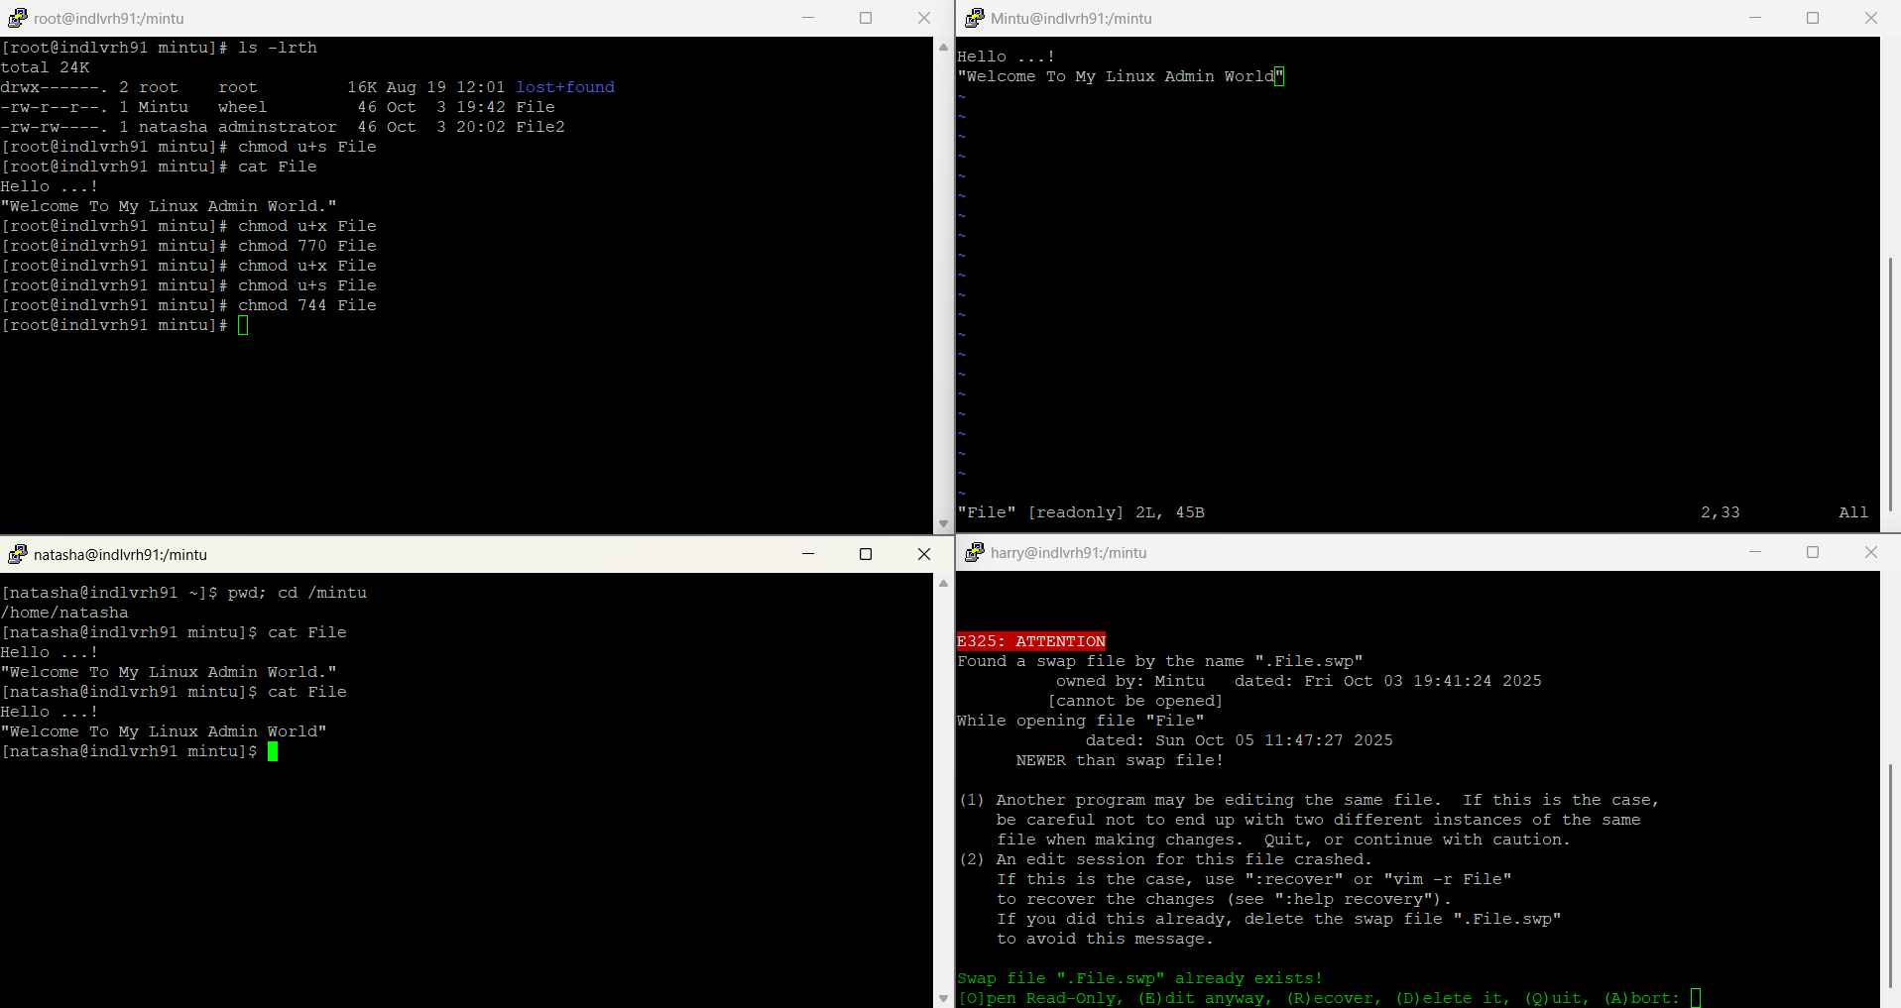

2. SGID (Set Group ID)
Purpose:
- On files: Runs with the permissions of the file's group.
- On directories: New files inherit the group of the directory, not the user's default group.
Example in a file:
[root@indlvrh91 mintu]# chmod g+s File2
Now File2 runs with the group adminstrator privileges.
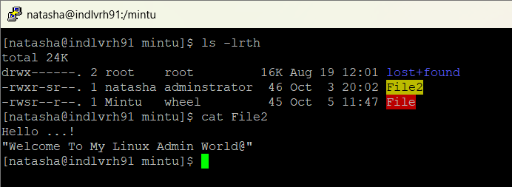

Example of a directory:
[root@indlvrh91 mintu]# mkdir shared_dir
[root@indlvrh91 mintu]# chown root:wheel shared_dir
[root@indlvrh91 mintu]# chmod 2775 shared_dir
Files created inside shared_dir will inherit the group wheel.
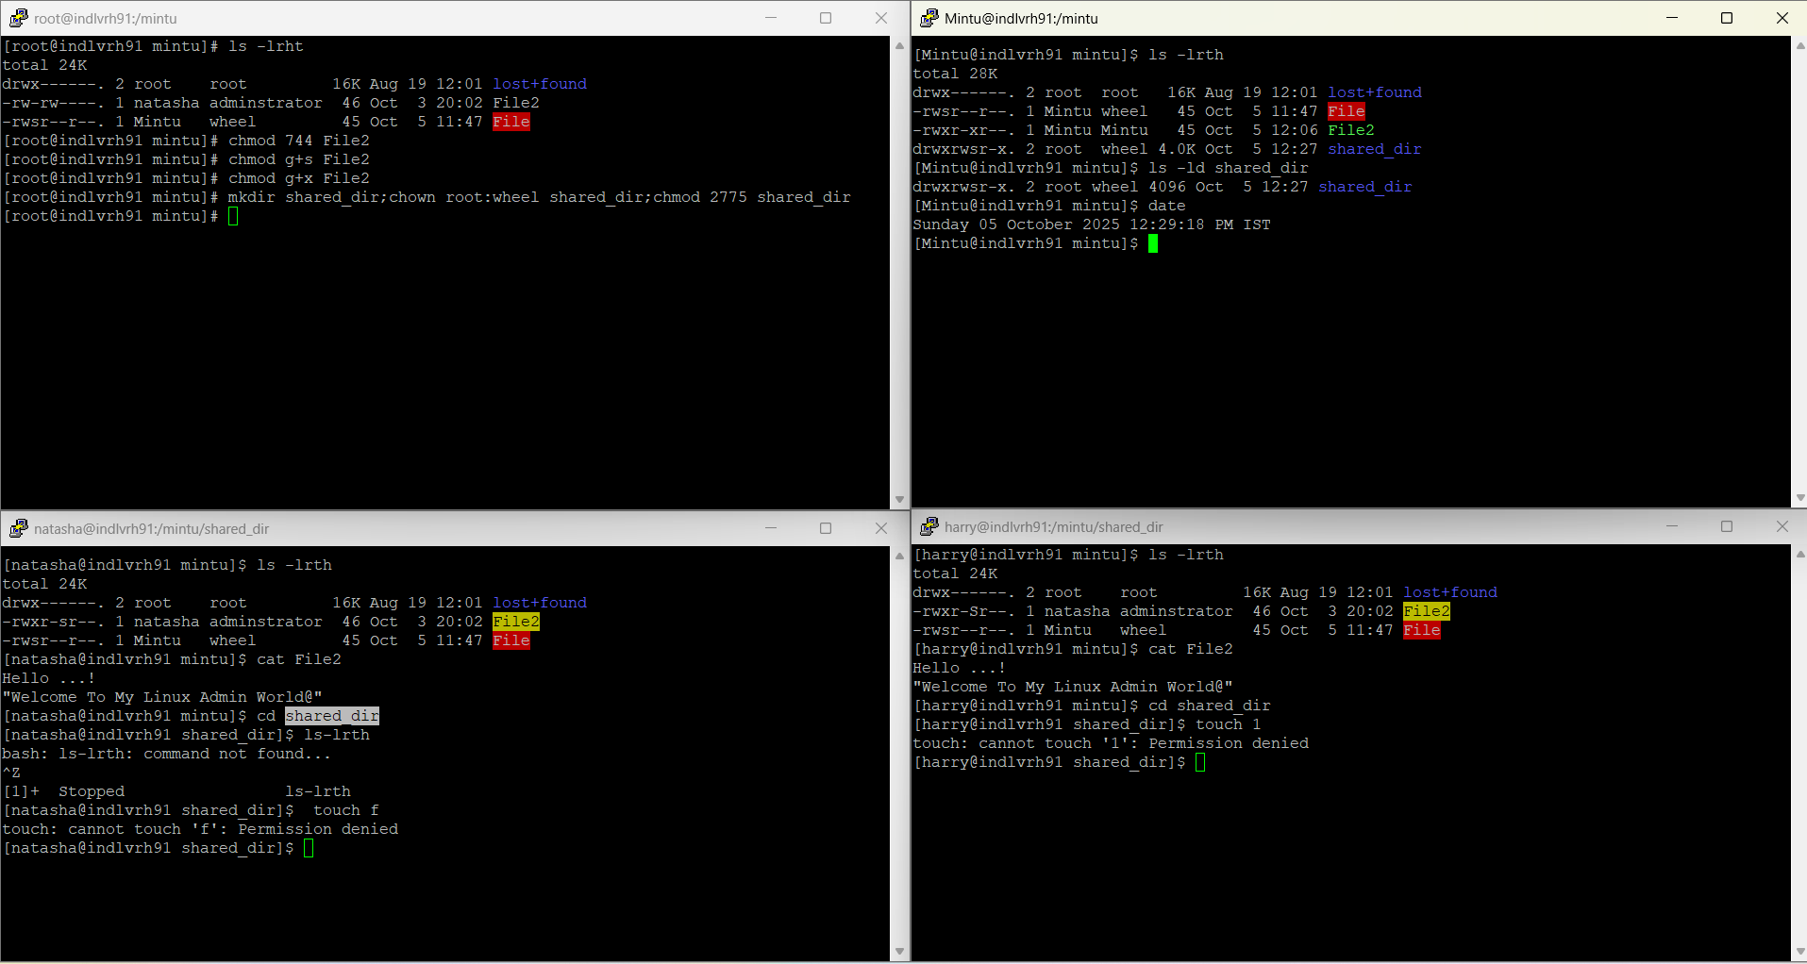

Check:
[root@indlvrh91 mintu]# ls -l
-rw-r-s--- 1 natasha adminstrator 46 Oct 3 20:02 File2
Note the s in the group execute position (r-s).

3. Sticky Bit

Purpose: Applied to directories to restrict deletion. Users can only delete their own files, even if others have write access.
Example:
[root@indlvrh91 mintu]# mkdir /mintu/shared
[root@indlvrh91 mintu]# chmod 1777 /mintu/shared
This is common for /mintu directories.
Check:
[root@indlvrh91 mintu]# ls -ld /mintu/shared
drwxrwxrwt 2 root root 4096 Oct 5 11:30 /tmp/shared
Note the t at the end of the permissions (rwt).

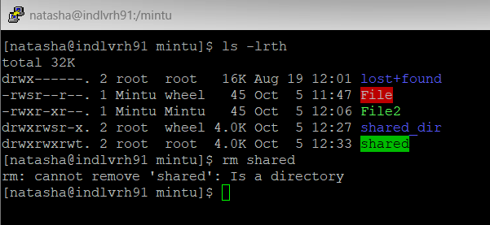

Bit | Command Example | Effect | Symbol
SUID | chmod u+s File | Runs with owner's permissions | rws
SGID | chmod g+s File2 | Runs with group’s permissions | r-s
Sticky Bit | chmod +t /tmp/shared | Only owner can delete their files in dir | rwt

Summary:

Command | Purpose | Syntax Example | Description
chmod | Change file/directory permissions | chmod 755 file | Sets read/write/execute for owner, read/execute for group and others
chmod | Change file/directory permissions | chmod u+x file | Adds execute permission to owner
chmod | Change file/directory permissions | chmod g-w file | Removes write permission from group
chown | Change file owner | chown mintu file | Changes owner to mintu
chown | Change file owner | chown mintu:wheel file | Changes owner to Mintu and group to wheel
chgrp | Change group ownership | chgrp adminstrator file | Changes group to adminstrator
chmod | Set SUID | chmod u+s file | File runs with owner's privileges
chmod | Set SGID | chmod g+s file | File runs with group’s privileges
chmod | Set Sticky Bit | chmod +t directory | Only file owners (or root) can delete files in the directory
chmod | Combine SUID, SGID, Sticky Bit | chmod 6755 file | SUID + SGID + rwx for owner, rx for group and others

